PRACTICAL QUESTIONS FOR DATA VISUALISATION AND ANALYTICS (CIA1C11)
Practical 5 – Data Preparation and Analytics I (Data Cleaning)

Introduction: At the end of EDA, the data analyst will have a pretty good assessment of what needs to be done to improve the data quality. The next step is therefore to execute the data preparation process to make the data more useful and efficient downstream. Generally, these are the things that are involved:
- Data Cleaning – remove errors/anomalies, handle missing values, re-format data type, split or extract substrings, conform data to standardized pattern (lower/upper case)
- Data Transformation – recode/discretize, derive new fields, aggregate, de-duplicate, normalize
- Data Reshaping/Joining – transpose data, join data, concatenate data

Practical 5-6 will cover various aspects of Data Preparation.

Objective: The aim of Practical 5 is to focus on techniques for data cleaning and data reshaping.

Question 1 : To reshape data (transpose) and clean data (handle substring, data type, missing value)
Question 2 : To analyze the prepared data using visualizations (line and stacked column chart, pie chart, line chart)

Dataset: For our task this week, we will make use of a dataset containing Singapore’s Gross Domestic Product at 2010 Market Prices, by Industry, presented on a quarterly basis. GDP data collected from 1975 Quarter 1 to 2016 Quarter 4 will be used. For more details, you can visit Singapore Department of Statistics at this link (https://www.singstat.gov.sg/find-data/search-by-theme/economy/national-accounts/latest-data)

Ready? Let’s get started!

Question 1 (Reshaping data, String manipulation, String to Number, Missing Value, Column Filter)
Unlike the previous datasets that we have encountered, the format of the dataset does not follow the guidelines set out according to Tidy Data. The purpose of this question is to prepare data by:
- Reshaping data (transpose)
- Cleaning data (extract substring, change data type, handle missing value, filter column) the data and prepare it for analysis.
The questions to consider are:
- How should data be shaped such that it is conducive for analysis?
- How should missing data be handled?

- Read Data
Create a new KNIME Workflow P05_Q1 in the DAVA Workflow Group. Read the dataset gdp with missing.csv into KNIME using the File Reader node. Be sure to set it such that the row IDs are read.

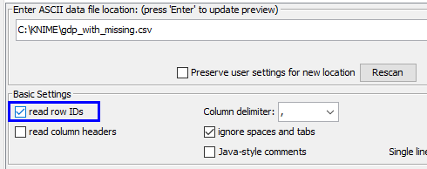

Execute the node and look at the output (right click File Table).

The dataset contained GDP details for Singapore, collected from 1975 onwards.
You can see that the format of the dataset does not follow the guidelines according to Tidy Data.

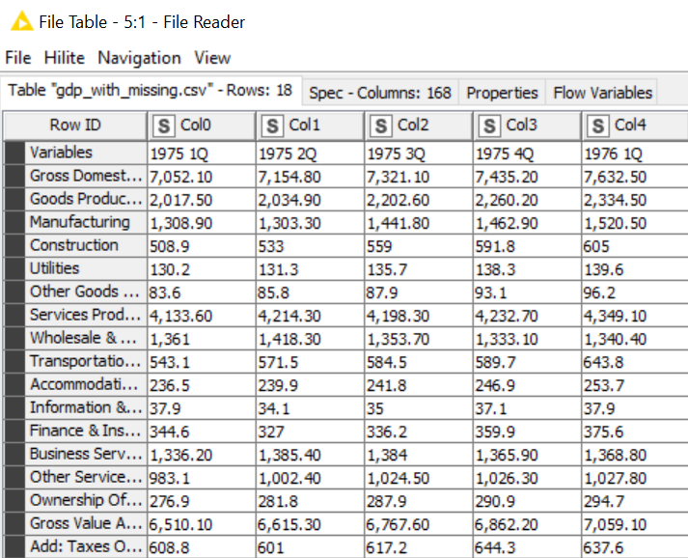

 | Discussion: How should tidy data look like in this case?  What is not ideal about the dataset we have?
Answer:

Ideally, we want each row to be a period (1975 1Q, 1975 2Q, … etc.), and each column to be one variable (Manufacturing, Constructions, … etc.)

Our dataset has the columns and rows swapped.

- Reshape Data – Transpose
Add a Transpose node downstream from the File Reader node. Execute the node.

From the node documentation:

“Transposes the entire input table by swapping rows and columns. The new column names are provided by the former (old) row IDs and the new row identifiers are the former (old) column names.”

- Take a look at the output (Right Click > Transposed Table).
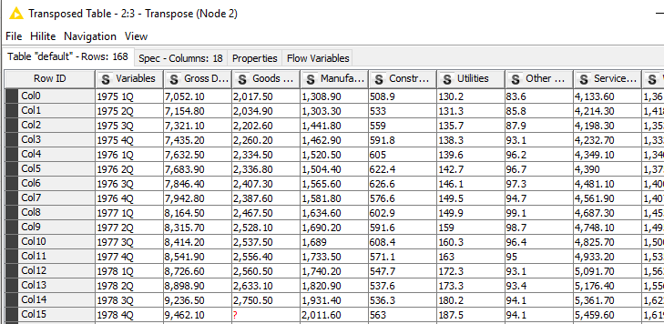
You can see that each row is now one time period (observation) and each column is one variable about the time period.

- Clean Data – Extract Sub-string
Now that our dataset is transposed, we can proceed to process the fields. Since we want our analysis to be by year, we first start by separating the Year and Quarter from the Variables field. Add a String Manipulation node (under Manipulation) downstream. Use the expression substr($Variables$,0 ,4) to extract the 4 left-most characters from the Year_Qtr field.

Select the option to append a new column for the derived data, call this new column Year.
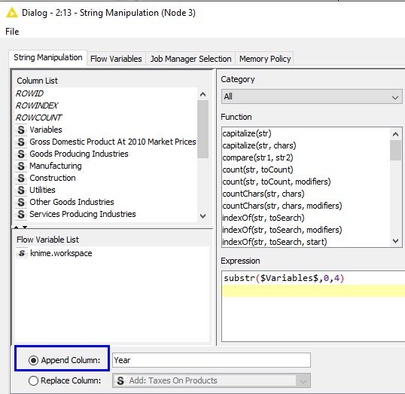
Execute the node and view the output table.
You should see a new field called Year occupying the right-most column.
Since the node is for string manipulation, the newly generated field is also a String type.

- Clean Data – Extract Sub-string
Repeat step 4, but this time, use substr($Variables$,5,2) to capture the Quarter from Year_Qtr field. Append a new column for the derived data, call this new column Quarter.

- Transform Data – Change Data Type
Note that many of the columns with numbers are read in as String type. We need to convert them to numeric type.

Add a String to Number (under Column, and not PMML) node downstream.
Configure this node as follows:
- Select all fields except Variable, Year and Quarter.
- Convert the fields to Number (double).
- Set fullstop (.) as the decimal separator
- Set comma (,) as the thousands separator

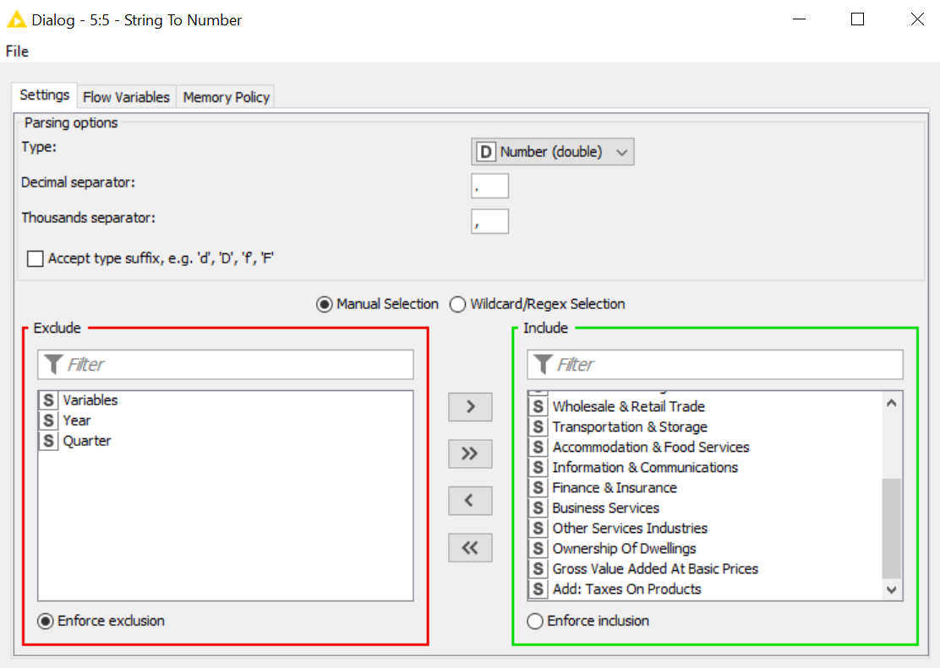

- Transform Data – Change Data Type
Add another String to Number node downstream.
Configure this node as follows:
- Select Year field to convert
- Convert the field to Number (integer)
- Leave the thousands separator empty since the Year field does not have one.
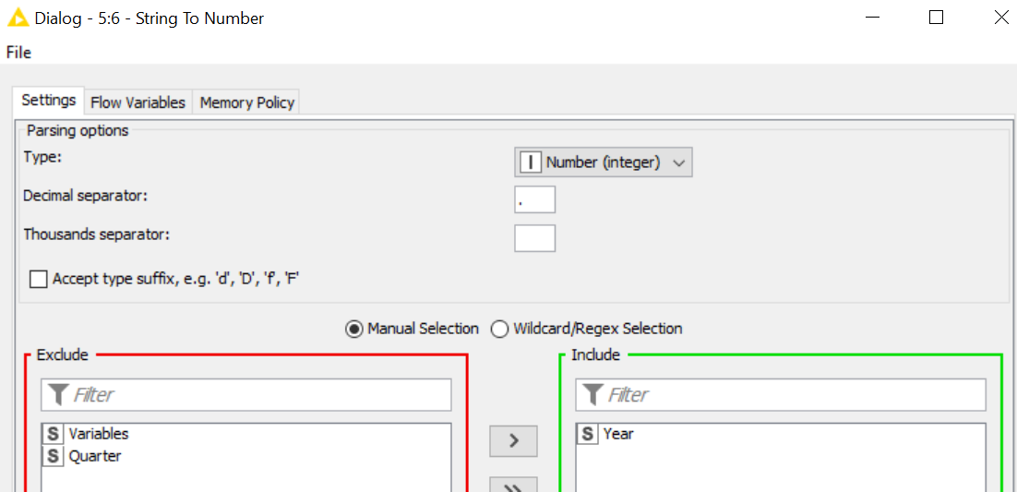

Your workflow should resemble the one shown below.

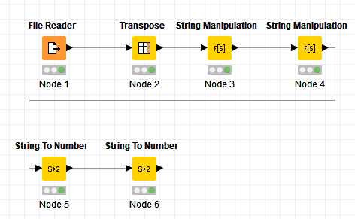

Execute the String to Number nodes, check in the output that the type of the fields had been transformed.
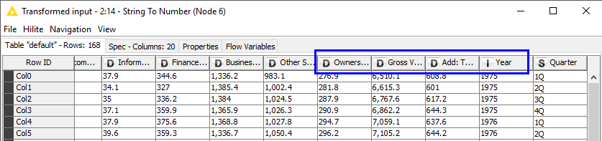

- Inspect Data – Use Statistics Node to find Missing Values
We will now take care of missing values in our table. Add a Statistics node downstream from the String to Number node and execute it. Identify the 3 fields with missing values.

Ans:

- Clean Data – Handle Missing Values
Add a Missing Value node (the one without apply) downstream from the String to Number node. The Missing Value node allows you to define default behaviour based on the type of missing data.

You can also define column-specific missing value handling strategies. Open the configuration window for the Missing Value node, navigate to the Column Settings tab.

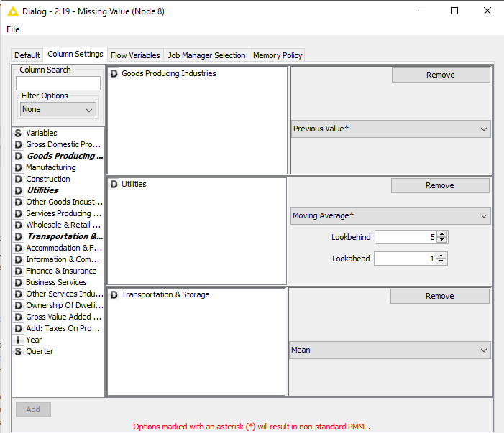

- Select Good Producing Industries, set Previous Value as the impute method.
- Select Utilities, use Moving Average Lookbehind 5, Lookahead 1 as the impute method.
- Select Transportation & Storage, use Mean as the impute method.
Run the Missing Value node. Verify that there are no more missing values (you can add another Statistics node to verify this)
 | Discussion: The Missing Value node will produce warning about non-standard PMML. Find out what that is.
Answer:

PMML = Predictive Model Markup Language. It is an XML-based language that enables the definition and sharing of predictive models between applications (e.g. between KNIME and SAS).

The option that we have selected will result in non-standard PMML for our workflow, this means we won’t be able to port our work to another analytics software. This is fine for our purpose since we have no plans to port our work to another platform.

- Clean Data – Remove Redundant Column
Add a Column Filter (the one without PMML) node downstream. Exclude the Variables column. Execute the node.

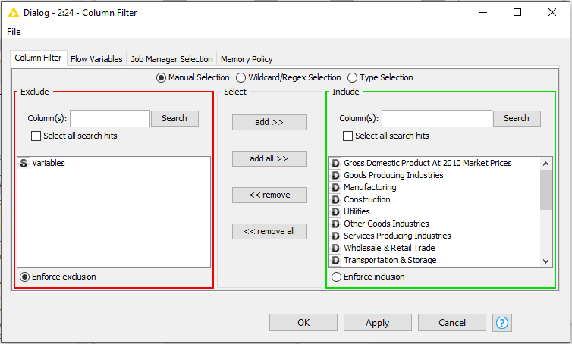

- Write to CSV File
We want to write the prepared data into a CSV file.
Add a CSV Writer node downstream.
Set the output location, in this case, I am writing the data into a file called “gdp_out.csv” in my C:\KNIME\Output folder. So click on This PC Double-click on Local Disk (C:)
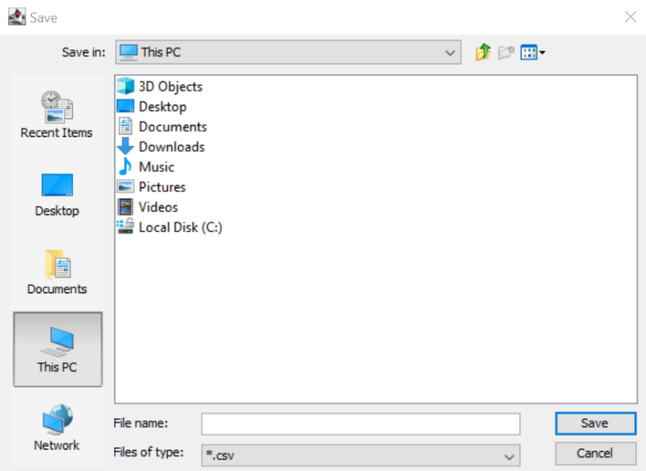

Double-click on KNIME folder
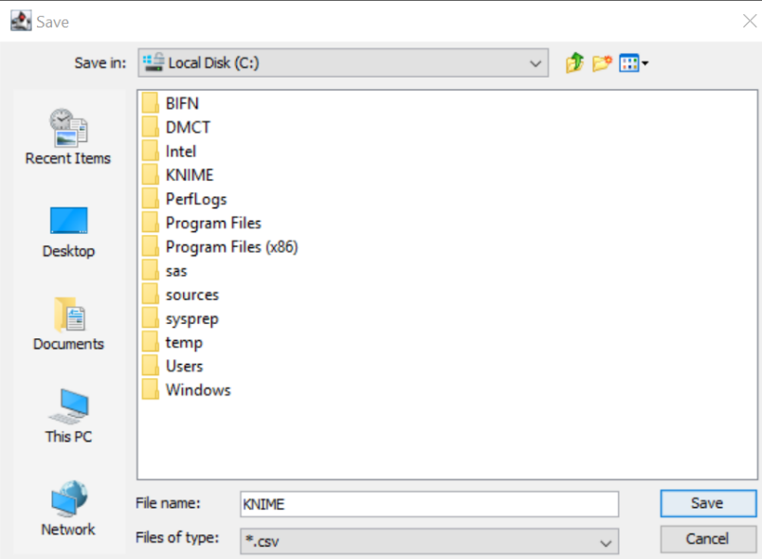

Click on New Folder (see icon below) Type Output as the name of the new folder.
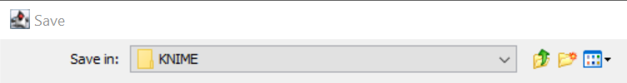

Double-click on the Output folder Ensure that the path is captured as C:\KNIME\Output

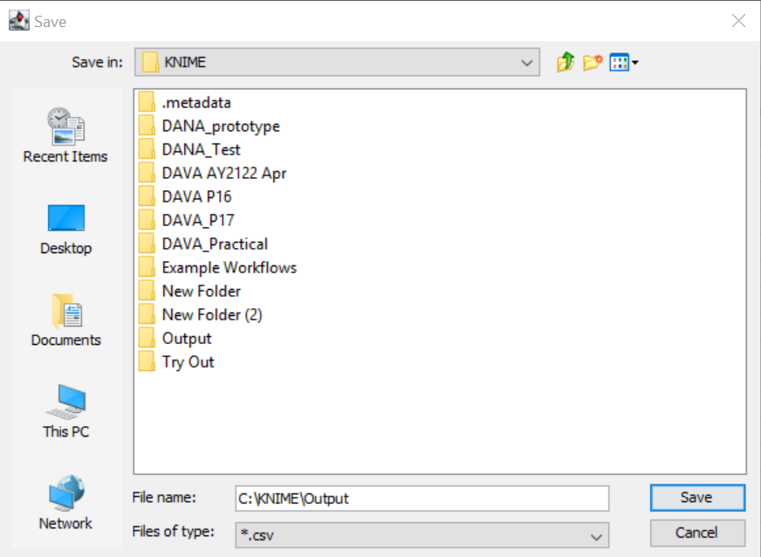

Click inside the box for File name Type gdp_out Click Save.
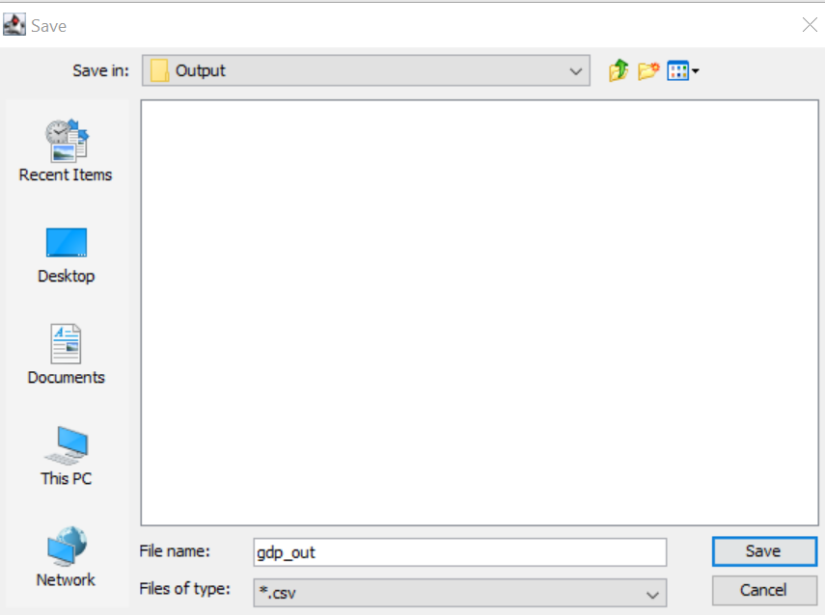

You can set a different filename / folder but be sure to add the file extension (.csv) and take note of the location it is saved. We will need this file for Question 2.

Choose option to Write Column Header.
If the file exists, select Overwrite.
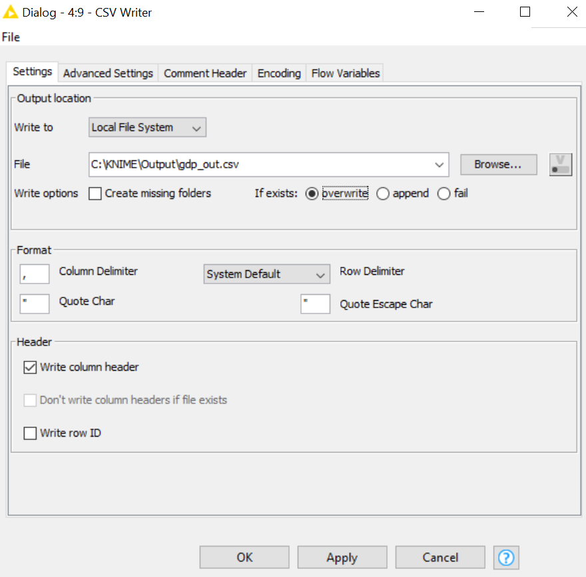

Navigate to the output location. Check that the csv file is there.

Your workflow should resemble the one shown below.

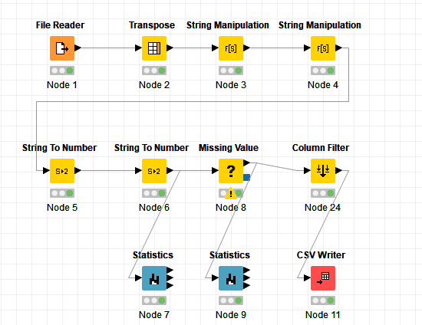

Save your workflow.

Question 2 (Visualizing Prepared GDP Data)
We will now read the CSV file prepared in Question 1 into Power BI desktop. This will allow us to prepare visualizations using line and stacked column chart, pie chart and line chart.
In the process of exploring the data, we may be able to discover things such as:
- Do Goods Producing Industries or Service Producing Industries contribute more towards Singapore’s GDP?
- Which industry is the major contributor in the Goods Producing industries?
- How has Singapore’s GDP changed over the years?

For Mac Users : Use Power BI Service

Sign in to Power BI Service (in the cloud) Click Get Data Click Get Under File Select Local File Navigate to gdp_out.csv and select file. You should see the dataset gdp_out.csv in Power BI Service. Click ⁞ next to gdp_out.csv Select Create Report. A blank canvas will appear in Report View. You can then continue to step 3.

- Get Data
Launch Power BI desktop.
Select File > Get Data > Text / CSV
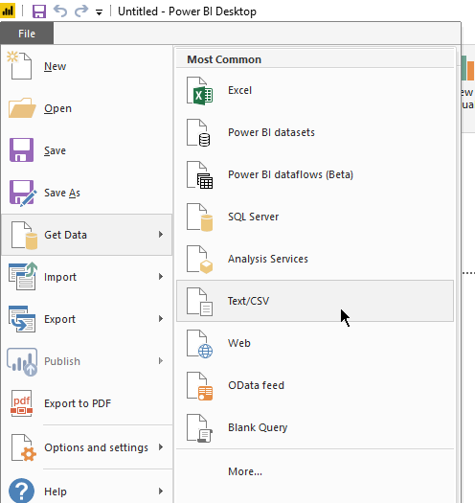

- Located the gdb_out.csv file and point Power BI to it.
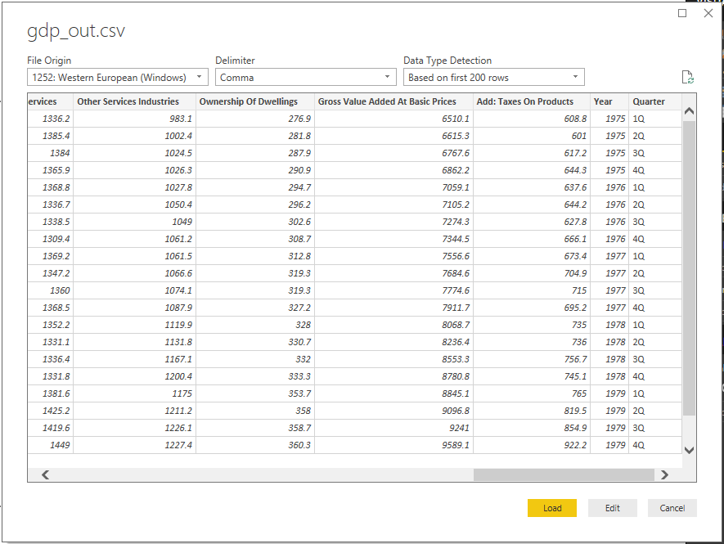
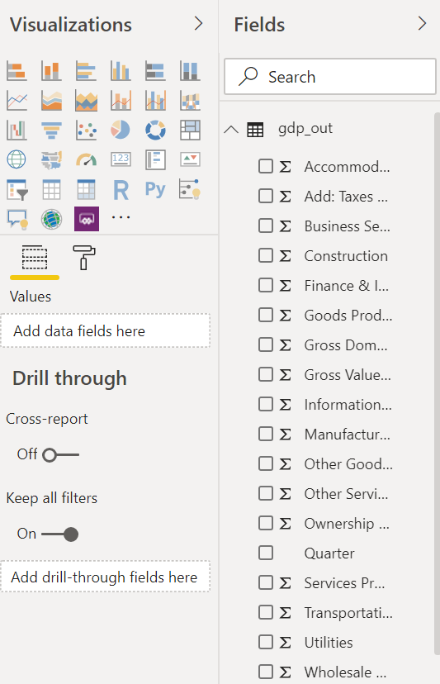
Click on the Load button. You should see the fields loaded on the panel on your right.

- Line and Stacked Column Chart
Click on the Line and stacked column chart in the Visualizations Pane (second row, fourth icon).
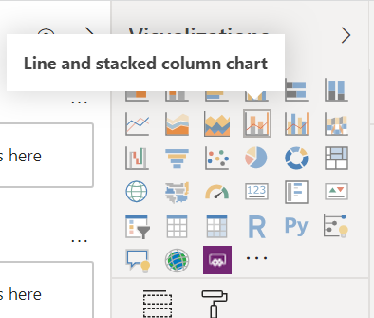

You should see a chart appearing in your Page 1 sheet.
Make the following selections:
- Add Year as the Shared axis
- Add Goods Producing Industries as the Column values
- Add Services Producing Industries as the Column values
- Add Gross Domestic Product as the Line values
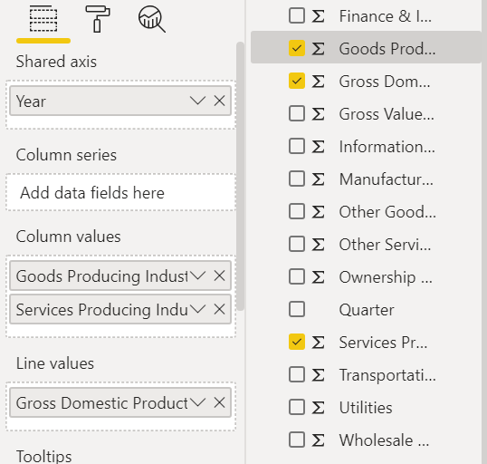

- Click on the focus mode icon to have a closer look at your first Power BI visualization.
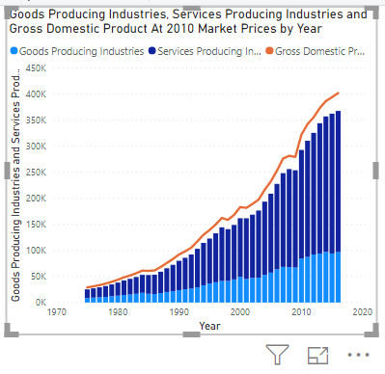

 | Question:  - Do Goods Producing Industries or Service Producing Industries contribute more towards Singapore’s GDP?
Answer:

Based on the visualisation (Power Bi), we can see that Services Producing Industries contribute more towards Singapore’s GDP because the bar for Services Producing Industries is much taller than the bar for Goods Producing Index.

 | Discussion: What about the gap between the stacked bars and the line, what other contributors are missing?
Answer:

Take at look at the original data.
The other 2 contributors are:
- Ownership of Dwellings
- Add: Taxes On Products

Click on the Back to Report button to minimize the visualization.
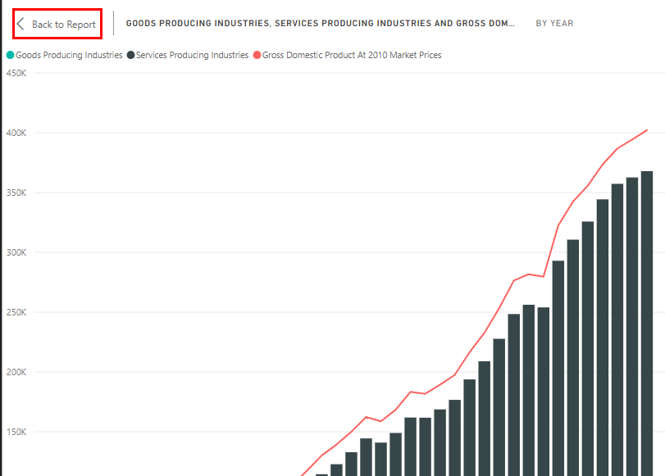

- Pie Chart
Let’s add another chart to our worksheet. This time, we will add a Pie chart.

At the moment, your Line and stacked column chart is selected (there are handles around the chart), clicking on another chart type in the Visualizations Pane will change the chart type of this selected chart. This is not what we want.

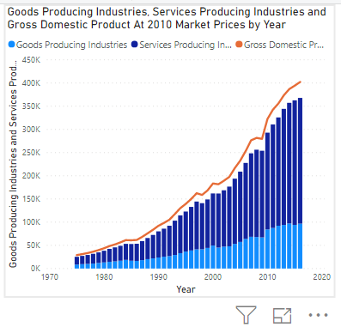

We want to add a new chart to our worksheet.

Chart is selected (notice handles around it) Chart is NOT selected (no handles around it)

Click on an empty space in your worksheet, this will unselect your current chart.

- Select Pie chart from the Visualizations Pane (third row, third icon)

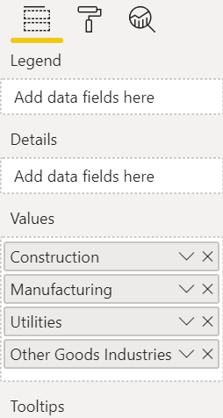
You should see a Pie chart added below / next to your Line and Stacked Column chart.
Add the following fields to the values shelf for your Pie Chart
- Construction
- Manufacturing
- Utilities
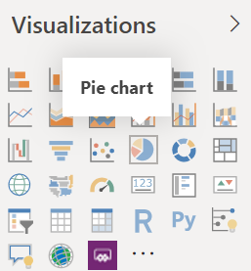
- Other Goods Industries

 | Question:  - Which industry is the major contributor in the Goods Producing industries?
Answer:

- Line Chart
Let’s add another chart to our worksheet. This time, we will add a Line chart.
Follow the same steps, that is, click on an empty space on your worksheet, ensure that neither of the existing charts are selected.

On the Visualizations Pane, select Line chart. This would add a Line chart into your worksheet.

Configure your chart as follows:
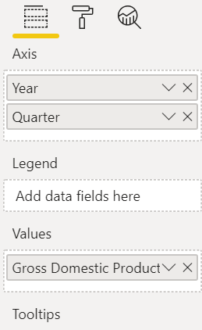
- Add Year as the field for Axis
- Add Quarter as the field for Axis (note, order is important, ensure Year is before Quarter)
- Select Gross Domestic Product as the field for Values
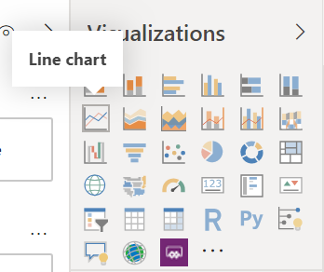

Having two fields set as axis would automatically turn on some additional features in the chart. Mouse over each of these to find out what they represent.
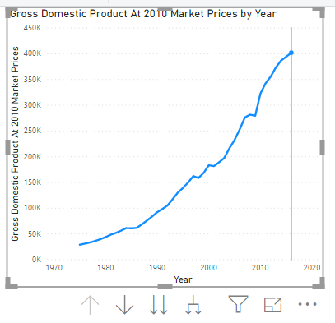

- Select the option to “Expand all down one level in the hierarchy” for your line chart. This should display the chart in a Year-Quarter fashion. (You can click on the ellipsis to adjust the axis sorting if required).

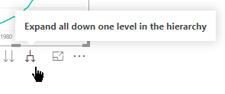

 | Question:  - How has Singapore’s GDP changed over the years?
Answer:
Based on the Line Chart, there is a healthy upward trend in the GDP, however there are dips in 1998, 2001, 2009

- Save your Power BI desktop file.
Click File > Save As
Give your file a meaningful filename (e.g. P05_Q2)

Question 3 (Practice Question – Will not be covered in class)
- The default colours for our charts in Question 2 is not very attractive.
Go to the Format tab in the Visualizations Pane to modify the colours for your vizzes.
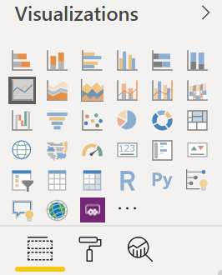

- 'Ask A Question'.
Double-click on an empty space on your canvas, this will launch the ‘Ask A Question’ feature in Power BI. For example, “average ownership of dwelling” or “utilities vs manufacturing”.

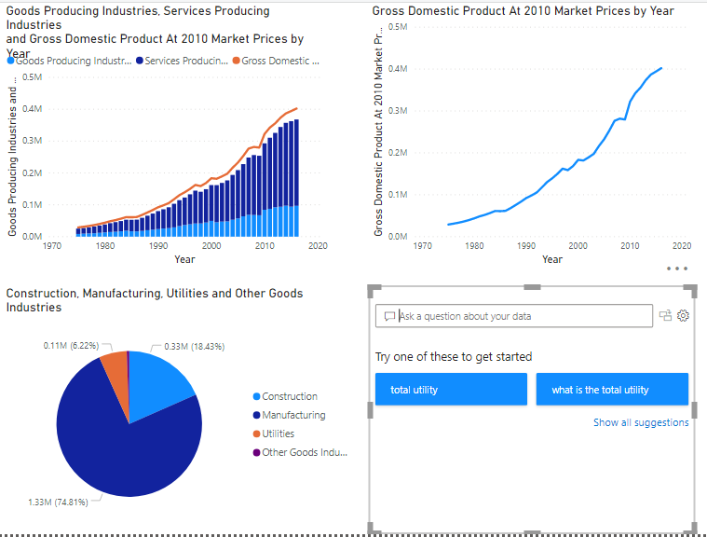
AB

– End of Practical 5 –

 | Summary:
In this practical we looked at how we can reshape raw data that is not in the correct form. We also looked at how we could carry out string manipulation and handle missing values. We also learnt how we can write the prepared data into CSV file and read this into Power BI desktop for visualization.

In this practical we made use of the following new nodes (not covered in previous practical) in KNIME.
Node |  | Purpose | Remarks
Transpose |  | Transform the input table by swapping rows and columns. | Old row IDs will become the new Column names. Old column names will become the new row IDs.
String to Number |  | Converts strings in a column to numbers. | Remember to set the thousands / decimal separator. If conversion fails, node will introduce missing values.
Missing Value |  | Handle missing values found in input table. Can either set a default handling method (by type) or column-specific handling strategies. | Options marked with an asterisk (*) will result in non-standard PMML.  Non-standard PMML uses extensions that cannot be read by other tools.  PMML = Predictive Modelling Mark-up Language. It enables the definition and sharing of predictive models between applications
Column Filter |  | This node allows you to filter out unwanted columns | Nil.
CSV Writer |  | Writes table to CSV file. | You need to enter the filename as well as extension (e.g. myOutput.csv).  Note the three options for “If file exists…”

